FEATURES OF JAVA 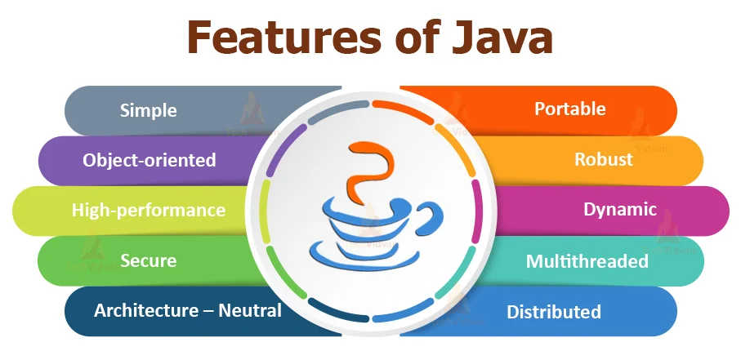

Java is an Object-Oriented Programming language. It was developed by James Gosling in collaboration with Mike Sheridan, and Patrick Naughton in the year 1995. Following are the main features of the Java language

→Simple

→Object Oriented

→Platform independent

→Secure

→ Robust

→Portable

→Dynamic

→Interpreted

→Portable

→High Performance

→Distributed

→Multithreading

**SIMPLE:**

Java is user-friendly.

Its syntax is clear and concise making it suitable for both aspiring programmers and experienced professionals.

It inherits many features from C, C++ and removes complex features like pointers, operator overloading, multiple inheritance, explicit memory allocation etc…

**OBJECT ORIENTED:**

→Java is an Object Oriented Programming language.

→Everything in JAVA is an Object, Object is a real world entity.

→Java supports Fundamental concepts of OOPs-

* Object
* Class
* Inheritance
* Polymorphism
* Abstraction
* Encapsulation

# **PLATFORM INDEPENEDENT:**

Unlike other languages, Java is not limited to any specific machine and dependent on other factors to run. The Java platform is independent because:

→It uses a runtime environment of its own, i.e. JVM.

→ It is a write-once, run-anywhere language.

→ It is a software-based platform that runs on top of other hardware-based platforms.

# **SECURE:**

→Java is better known for its security, Java is secured because:

→No explicit Pointer

→Java runs inside a virtual machine(JVM)

→In Java run time, a class loader separates the package for the classes of the local file system from the files imported from network sources.

→ Java also consists of Bytecode Verifier, which checks the code fragments for illegal code.

# **ROBUST:**

Java is robust because of following:

→ Built-in Exception handling.

→Strong type PORTABLE:

→ Java is portable because it facilitates you to carry the Java bytecode to any platform. It doesn't require any implementation.

# **DYNAMIC:**

→ Java is a dynamic language. It supports the dynamic loading of classes. It means classes are loaded on demand. It also supports functions from its native languages, i.e., C and C++.

→Java supports dynamic compilation and automatic memory management (garbage collection).

# **INTERPRETED:**

→The source code is first compiled into bytecode by the Java compiler.

→Then this bytecode is interpreted by the JVM when the program runs.

**HIGH PERFORMANCE:**

→ Java is faster than other traditional interpreted programming languages because Java bytecode is "close" to native code.

→ It is still a little bit slower than a compiled language (e.g., C++).

→Java is an interpreted language that is why it is slower than compiled languages, e.g., C, C++, etc.

**DISTRIBUTED:**

→Java provides the network facility. i.e. programs can be access remotely from any machine on the network rather than writing program on the local machine.

→HTTP and FTP protocols are developed in java.

**MULTITHREADING:**

→Java provides multitasking facility with the help of lightweight processes called threads.